# First of all you need to follow this complete guide:

<https://coderrocketfuel.com/article/deploy-a-create-react-app-website-to-digitalocean>

**Then,** you can start configuring your react app:

1 - Change your **package.json,** add **homepage** variable and **make it empty**

{

"name": "example app",

"version": "0.1.0",

"private": true,

"dependencies": {

...

},

"scripts": {

"start": "react-scripts start",

"build": "react-scripts build",

"test": "react-scripts test",

"eject": "react-scripts eject"

},

"homepage": "",

}

**2 - npm run build and deploy to digital ocean**

**3 - now we need to change configurations for nginx**

sudo nano /etc/nginx/sites-enabled/default

Then change location field just like on the screenshot

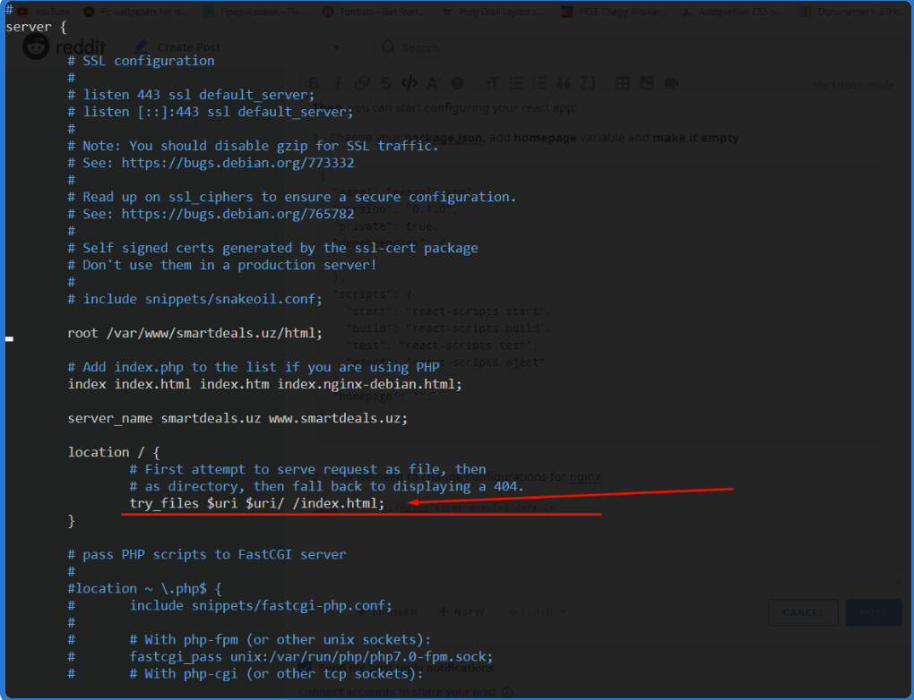

location

There is 1 more server object inside of default file, it should be similar to

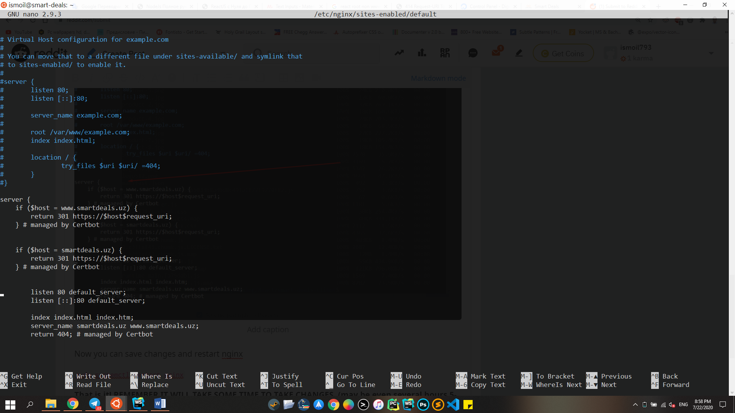

Now you can save changes and restart nginx

sudo systemctl restart nginx

**REMEMBER IT WILL TAKE SOME TIME TO TAKE CHANGES**

**HOW TO OPTIMIZE YOUR files img,css and etc. and add it for cashing to speed up your app ?**

Add the following to sites-enabled default parameter of nginx:

